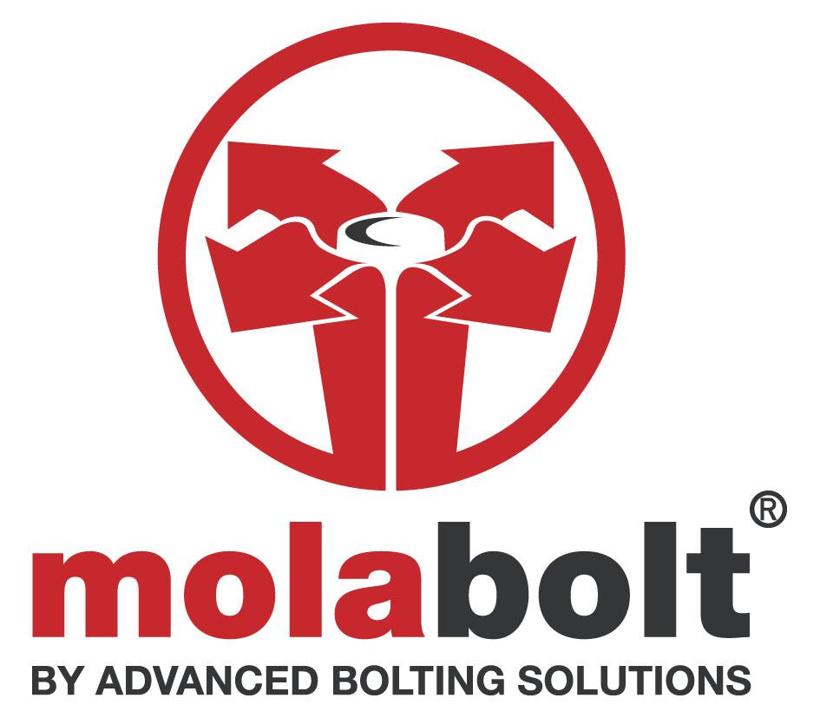

GUIDANCE NOTE #3 – Drilling Dimensions and Measurements (PEG ANCHOR)

1. INTRODUCTION

This guidance note provides details on drilling guidance including drilled-hole sizes calculation and centre-to-centre and edge-to-centre pitch measurement.

2. Drilling dimensions

2.1 Drilled holes may exceed the recipient bolt dimension, but only in line with the guidance below, which addresses BS5950 requirements ( Clause 6.2.2.3 Oversize Holes)..

We recommend a maximum clearance hole of + 0.1mm on sizes M8 – M14 and a maximum clearance hole of +0.2mm on sizes M16 – M24. Where distance-from-edge is a consideration for drilling, this additional tolerance may have the effect of requiring that the nominal centre of the bolt be moved further into the structure to reflect this. Over sized holes greater than the recommended tolerances set out above should be avoided.

2.2 For slotted holes, the following guidance is provided to meet BS5950 requirements (Clause 6.2.2.2 Slotted Holes):-

Peg Anchor should not be anchored into irregular -shaped holes, but may pass through irregular-shaped hole into parent /anchoring material which has standard tolerance relative to bolt diameter. If applied in this way, the bolt will comply with the code.

3. Minimum Pitch (bolt centre- to- bolt centre) Dimensions

Minimum pitch M10 = 29mm M12 = 35mm M14 = 40mm
" " M16 = 45mm M20 = 50mm M22 = 62mm

M24 = 70mm

4. Minimum Edge Distances (measured to centre of drill-hole)

M8 = 9mm M10 = 10mm M12 = 12mm M14 = 14mm

M16 = 16mm M20 = 20mm M22 = 22mm M24 = 24mm

Note: Hollow section wall thicknesses must be added to the above figures; for example, where a 10mm Peg Anchor is being inserted into steel with a 7mm wall thickness, the minimum distance from the edge to centre of drill hole is 10 + 7 = 17mm.See also para 2.1 above.

For items with a non-stock diameter, please contact our sales department for further advice on (0116) 251 2251.

